|  |  |
| --- | --- |
|  | **Final Year Project Synopsis**  **B.Tech.(CSE)-Session 2019-2020** |

|  |
| --- |
| **PLANT DISEASE DETECTION**  **USING MACHINE LEARNING** |

|  |  |  |
| --- | --- | --- |
| **GroupNo.:** 76  **ProjectGroup Members:**   |  |  | | --- | --- | | 1. Rambandhu Sharma (161500438) 2. Devesh Thakur (161500195) | 1. Rajeev Kumar (171599007) 2. Paritosh Pandey(161500374) |   **Project Supervisor:** Mr. Shashi Shekhar, Assistant Professor |

**About the Project:**

To develop a tool that uses plants leaf to detect the diseases of the leaves using machine learning.

When plants and crops are affected by pests it affects the agricultural production of the country. Usually farmers or experts observe the plants with naked eye for detection and identification of disease. But this method can be time processing, expensive and inaccurate. Automatic detection using image processing techniques provide fast and accurate results. This paper is concerned with a new approach to the development of plant disease recognition model, based on leaf image classification. There are several ways to detect plant pathologies. Some diseases do not have any visible symptoms, or the effect becomes noticeable too late to act, and in those situations, a sophisticated analysis is obligatory. However, most diseases generate some kind of manifestation in the visible spectrum, so the naked eyes examination of a trained professional is the prime technique adopted in practice for plant disease detection.

**Motivation:**

The main motive of this project to get the knowledge of the plant diseases because some of the people are unaware of plants their type thy get affected by touching them. We can use python libraries like tensorflow, keras, Opencv, which provides many inbuild function for image processing to detect plant disease using machine learning. It should be count as a major project because it has variety of scope in wide range of areas specially in agricultural fields.

**Project Planning:**

First, we will install all modules and libraries required in the project. Then collect the data set of plants from kaggle of PlantVillage dataset. Thenimplement the module to train this tool.

**Gantt Chart:**

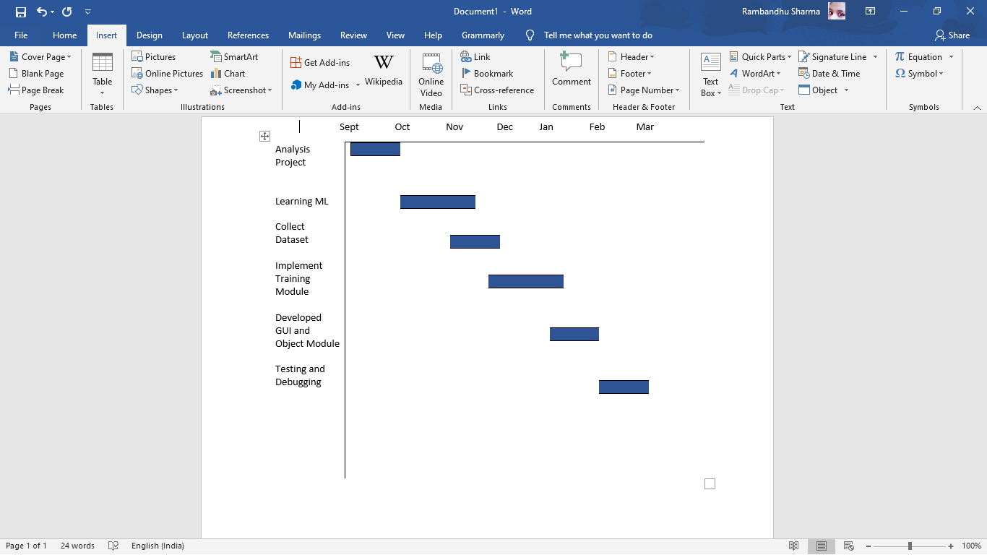

**Tools Required:**

**Hardware Requirements:**

* 8GB RAM
* 4GB Graphic Card
* Intel i5

**Software Requirements:**

* Python IDE
* Machine Learning Libraries

**Signature of Project Supervisor:__________________________**